**Software Requirement Specifications**

**Event Craft**

**Version: [1.6]**

|  |  |
| --- | --- |
| Project Code | S24-100 |
| Supervisor | Farooq Zaidi |
| Co Supervisor | Fahad Hussain |
| Project Team | Qazi Zain – 20k1038  Zain Ul Abdin – 20k1672  Ali Khaf Ul Wara – 19k1066 |
| Submission Date | 16-May-2024 |

**Document History**

|  |  |  |  |
| --- | --- | --- | --- |
| **Version** | **Name of Person** | **Date** | **Description of change** |
| 1.0 | Zain ul Abdin | 08-04-2024 | Start Documentation |
| 1.1 | Ali khaf | 17-04-2024 | Functional and non-Functional Requirement |
| 1.2 | Zain Ul Abdin | 21-04-2024 | Review Requirements |
| 1.3 | Zain Ul Abdin | 29-04-2024 | Context diagram and Hierarchy function Requirements |
| 1.4 | Ali | 06-05-2024 | Scope, System Contains and use case |
| 1.5 | Qazi Zain | 10-05-2024 | Use case completion |
| 1.6 | Zain Ul Abdin | 14-05-2024 | Review whole document |

**Distribution List**

|  |  |  |
| --- | --- | --- |
| **Name** | **Role** | |
| Farooq Zaidi |  | Supervisor |
| Fahad Hussain |  | Co- Supervisor |
|  | |  |

**Document Sign-Off**

|  |  |  |
| --- | --- | --- |
| **Version** | **Sign-off Authority** | **Sign-off Date** |
|  |  |  |
|  |  |  |
|  |  |  |
|  |  |  |
|  |  |  |
|  |  |  |
|  |  |  |

**Table of Contents**

1. Introduction 6

1.1. Purpose of Document 6

1.2. Intended Audience 6

1.3 Abbreviations 6

1.4 Document Convention 6

2. Overall System Description 7

2.1. Project Background 7

2.2. Project Scope 7

2.3. Not In Scope 8

2.4. Project Objectives 8

2.5. Stakeholders 8

2.6. Operating Environment 8

2.7. System Constraints 8

2.8. Assumptions & Dependencies 9

3. External Interface Requirements 10

3.1. Hardware Interfaces 10

3.2. Software Interfaces 10

3.3. Communications Interfaces 11

4. Functional Requirements 12

4.1. Functional Hierarchy 12

4.2. Use Cases 13

4.2.1. [Title of use case] **Error! Bookmark not defined.**

5. Non-functional Requirements 13

5.1. Performance Requirements 27

5.2. Safety Requirements 27

5.3. Security Requirements 27

5.4. User Documentation 27

6. References 28

7. Appendices 28

# Introduction

### 1.1. Purpose of Document

The purpose of this Software Reequipment Specification (SRS) document is to give detailed description and outline the functional and nonfunctional requirement of “Event Craft”. Furthermore, this document includes goal, scope, objective, and system functionalities of system.

### 1.2. Intended Audience

The intended audience for this document includes Developers, Manager, Quality Assurance, Service Providers , users and anyone who involved in the development, quality assurance and deployment process of this system.

### 1.3 Abbreviations

Not applicable.

### 1.4 Document Convention

Fonts Styles: Arial for heading and subheadings, Calibri content table.

Font Size: 12 for sub-headings,10 for description, and 16 headings

# 2. Overall System Description

### 

### 2.1. Project Background

In today’s fast-paced world, people often find them overwhelmed while planning their events. Planning personal events is often a hectic and frustrating experience, particularly for young professionals who juggle busy schedules and budget constraints. Managing complex logistics, like venue booking, vendor coordination, and guest invitations, can be overwhelming and lead to anxiety and inefficiency. This often results in compromises, limiting the ability to create truly memorable moments. It is lengthy, time consuming and complex process. Like: selecting right venues, listing best food. Also, it is very challenging to communicate the venders, guest and helper which are coordinating too organizing the event.

Our project aims to solving this problem more effectively and efficiently. Furthermore, we noticed that there is not any existing product or application which is addressing this problem statement with user friendly interface. Yes, there are some application and website which helps bit, but they are not addressing this problem properly. They are making this process more complex or leave the import asset of the problem statement.

This gap presents a significant opportunity for us to develop a comprehensive event management system which not only simplifies the event planning process, but also enhances the overall experience of event, save the planning time and cost.

Basically, the project is driven by the desire to revolutionize the event planning industry by offering a solution that not only meets but exceeds the expectations of users. Through strategic integration of features, seamless user experience, and collaboration with service providers, we envision a platform that sets a new standard for event management, ultimately enhancing the joy and satisfaction of event organizers and participants alike.

### 2.2. Project Scope

The scope of our project is to encompasses the development of an extensive event management system, our aim to streamline the process which will be held during the organizing an events. It can be birthday or wedding reception. The main idea develops this system is to create use friendly HCI base application which

can manage all the aspect of event. Users will be able to login to their accounts and utilize features such as time scheduling and checklist management to effectively plan their events. This system will also facilitate collaboration by allowing users to designate helpers who is helping to organized an event, by assign tasks, ensuring coordination throughout the planning process and organizing process.Furthermore, this system will offer recommendations for event planning based on budget constraints, time and depending on area. System will allow user to guest management features which will listed guests, and send them invitations. In Addition, this system will also provide AI-generated e-cards for event invitations. Furthermore, users will have access to a wide range of event components such as venues, catering, and decoration etc. On the other hand, Service providers will be able to customize their services within a framework. Service provider will receive notifications for payments and orders. Users and Service providers both can monitor their progress of an event.

### 2.3. Not In Scope

* This project not coordinating with service provider, its third-party application.
* Admin which will manage the users and service provider accounts is also not be included.
* This application does not support for payment method.

### 2.4. Project Objectives

* The objective of this project is to provide with an interactive user-friendly platform that will helps to enable the Users to book venues, catering and many other things that are helping to create an event.
* We are establishing an online platform that is available to all users that want to provide or utilize the services that are being offered by the “Event Craft” platform.
* Platform which enables users to communicate with service providers and helpers which are coordinating to organizing an Event.
* Ensure system will provides availability, security, and performance of system.

### 2.5. Stakeholders

Following are the stakeholders:

* Users
* Service Providers
* Developers
* Testers
* Members
* Guests

### 2.6. Operating Environment

We are creating mobile application as well as web base application. In Mobile app and website both do not need any type of special environment or operation system. Mobile application needed android mobile and stable internet. On the other hand, web application will need web browser and stable internet.

### 2.7. System Constraints

* **Software Constraints**

This software will be opened on web Brower. Second, Software constrain is users’ application will be opened on mobile app.

* **Hardware constraints**

A server is necessary for service which are added by service providers, and which will be shown to users.

* **Cultural constraints**

Both mobile app and web site is in English.

* **Legal constraints**

Service Provider will be authentic people which providing services to users.

* **Off the shelf components**

Website will follow all the copyright and cyber laws of PTA.

* **Environmental constraints**

No environment contains.

### 2.8. Assumptions & Dependencies

Follows are the assumption and dependences.

* We assume that users and service providers will have a proper internet connection for this event management system.
* Service providers are willing to participate and collaborate within the system.
* Users and Service Provider, both are responsible for providing accurate and up-to-date information to application.
* This system will be developed using Human Computer Interaction(HCI) rules and practices.
* Dependence with API of map, users contact list, gallery and notification turn on.

# 3. External Interface Requirements

### 3.1. Hardware Interfaces

Basic input/output devices:

* Mouse
* Keyboard
* Display screen.
* Touch

For internet connection:

* WIFI
* Ether wire
* Mobile data

### 3.2. Software Interfaces

This system will integrate with third-party API to access external services. For example, mapping API (e.g., Google Maps API) for location-based services. Also, this API used for locating the service providers. Furthermore, over system will be compatible with Windows and Android operating systems. Users will access system using android application and service provider can access this system using web browser like: chrome. In Addition, over system is developed on React and React Native development languages , and database which used MySQL Spring Boot .

### 3.3. Communications Interfaces

The system will utilize standard network communication protocols such as HTTP/HTTPS for transmitting data between clients and servers over the internet. HTTPS will be enforced to ensure data security through encryption and authentication mechanisms.

# 4. Functional Requirements

## 4.1. Functional Hierarchy

### 

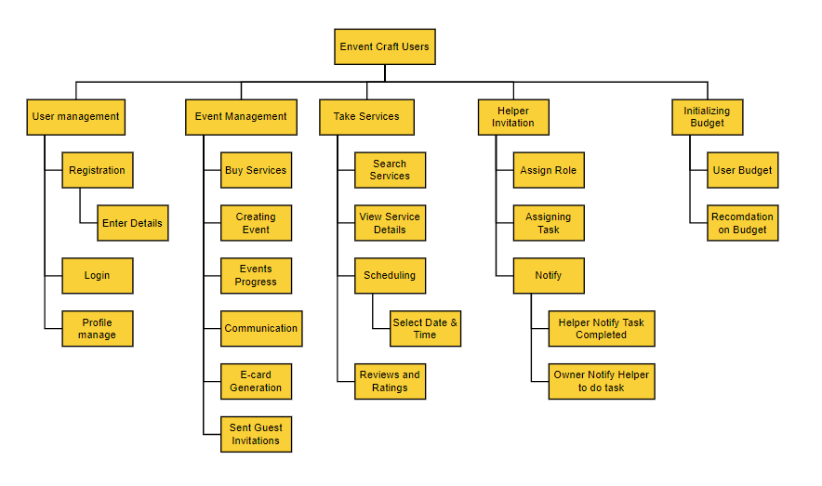

### 4.2. Use Cases

#### 4.2.1. Registration

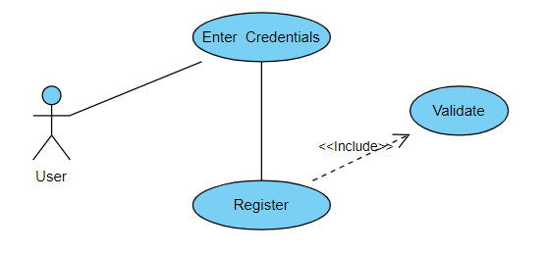

|  |  |  |  |  |
| --- | --- | --- | --- | --- |
| ***UC1 : Registration*** | | | | |
| ***Use case Id:*** | | *Uc1* | | |
| ***Actors:***  *Users and Service providers* | | | | |
| ***Feature:*** *Sign Up* | | | | |
| ***Pre-condition:*** | | *If use is not register.* | | |
| ***Scenarios:*** *Before using the application, users and service providers have to registered.* | | | | |
| ***Step#*** | ***Action*** | | | ***Software Reaction*** |
| ***1.*** | *First of all the user must click on the sign-up to enter their details and register* | | | *Redirects the user to the registration form.* |
| ***2.*** | *Enter email* | | | *Email or roll number’s format will be checked.* |
| ***3.*** | *Enter password* | | | *Password format will be checked* |
| ***4.*** | *Enter Name* | | | *Checks if the field is not empty.* |
| ***5.*** | *Click the button to register* | | | *Data will be verified and the user will be redirected to a specific interface upon successful creation.* |
| ***Alternate Scenarios:*** | | | | |
| ***1:*** *Users use wrong or incorrect email to login.*    ***2:*** *User not entered strong password .* | | | | |
| ***Post Conditions:*** *Successful creation of an account which can be used to login to the system.* | | | | |
| ***Step#*** | ***Description*** | | | |
|  |  | | | |
|  |  | | | |
|  |  | | | |
| ***Use Case Cross referenced*** | | | *-* | |

### 4.2.2. Login to System

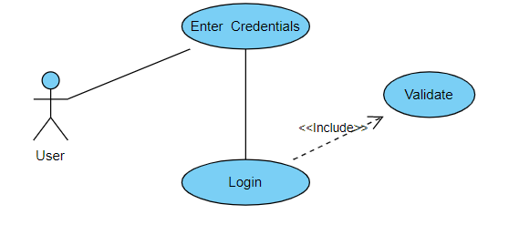

|  |  |  |  |  |
| --- | --- | --- | --- | --- |
| ***UC2 : Log-In to system*** | | | | |
| ***Use case Id:*** | | *Uc2* | | |
| ***Actors:***  *users and Service providers* | | | | |
| ***Feature:*** *Log-In* | | | | |
| ***Pre-condition:*** | | *Users and Service Provider should be registered on database before to Log-In.* | | |
| ***Scenarios:*** *Considering the user has registered already, he/she logs in to use the web application or mobile applications.* | | | | |
| ***Step#*** | ***Action*** | | | ***Software Reaction*** |
| ***1.*** | *First of all the user must click on the log-in to enter their details and process.* | | | *Redirects the user to the log-in page.* |
| ***2.*** | *Enter email address or roll number* | | | *Check if the email is correct and matches.* |
| ***3.*** | *Enter password* | | | *Check if the password matches.* |
| ***4.*** | *Click on the button to log-in* | | | *Authenticate and the user and proceed with the login process.* |
| ***Alternate Scenarios:*** | | | | |
| ***1 :*** *Users or service provider login failed, then they should reentered password and email.* | | | | |
| ***Post Conditions:*** *Successful authentication will lead the user to log into the system and use services.* | | | | |
| ***Step#*** | ***Description*** | | | |
|  | *Access to use the system will be granted to the user according to its type.* | | | |
|  |  | | | |
|  |  | | | |
| ***Use Case Cross referenced*** | | | *Uc1* | |

### 4.2.3. Profile Management

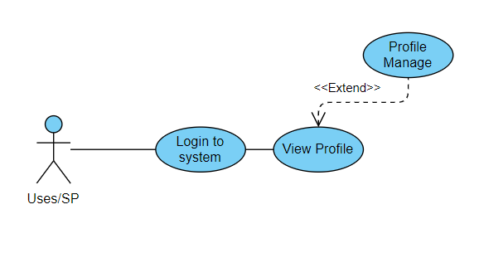

|  |  |  |  |  |
| --- | --- | --- | --- | --- |
| ***UC3: Manage Profile*** | | | | |
| ***Use case Id:*** | | *Uc3* | | |
| ***Actors:***  *users and Service providers* | | | | |
| ***Feature:*** *Manager Profile* | | | | |
| ***Pre-condition:*** | | *Users and Service Provider should be Log-In to the system.* | | |
| ***Scenarios:*** *user upload wrong data on system. He/She needed to be update that data.* | | | | |
| ***Step#*** | ***Action*** | | | ***Software Reaction*** |
| ***1.*** | *Enter email password* | | | *Login to the system* |
| ***2.*** | *Click on profile* | | | *Update and manage profile* |
|  |  | | |  |
|  |  | | |  |
| ***Alternate Scenarios:*** | | | | |
| ***1 :*** *Users or service provider login failed, then they should reentered password and email.* | | | | |
| ***Post Conditions:*** *Successful change the profile of user and service providers .* | | | | |
| ***Step#*** | ***Description*** | | | |
| ***1*** | *User's profile information is updated with the changes made.* | | | |
| ***2*** | *The system confirms the successful completion of the profile management task and displays a notification message to the user* | | | |
|  |  | | | |
| ***Use Case Cross referenced*** | | | *Uc2* | |

### 4.2.4. Add new Services.

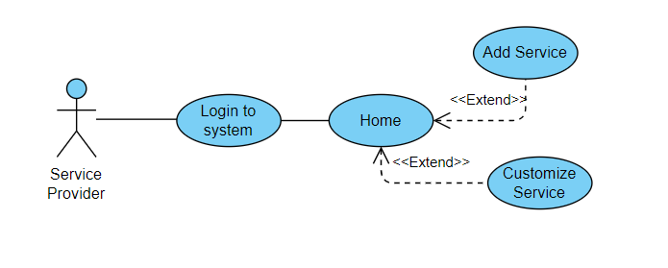

|  |  |  |  |  |
| --- | --- | --- | --- | --- |
| ***UC4: Add new Services*** | | | | |
| ***Use case Id:*** | | *Uc4* | | |
| ***Actors:***  *Service providers* | | | | |
| ***Feature:*** *Add new Services* | | | | |
| ***Pre-condition:*** | | *Service Provider should be Log-In to the system.* | | |
| ***Scenarios:*** *Services provider want to add new services.* | | | | |
| ***Step#*** | ***Action*** | | | ***Software Reaction*** |
| ***1.*** | *Enter email password* | | | *Login to the system* |
| ***2.*** | *Click on Add service button* | | | *Add new Services* |
|  |  | | |  |
|  |  | | |  |
| ***Alternate Scenarios:*** | | | | |
| ***1 :*** *Service not added.* | | | | |
| ***Post Conditions:*** *Successful change the profile of user and service providers.* | | | | |
| ***Step#*** | ***Description*** | | | |
| ***1*** | *Service will be available to users.* | | | |
| ***2*** | *Successful added service* | | | |
|  |  | | | |
| ***Use Case Cross referenced*** | | | *Uc3* | |

### 4.2.5. Customize Services



|  |  |  |  |  |
| --- | --- | --- | --- | --- |
| ***UC5: Add new Customize Services*** | | | | |
| ***Use case Id:*** | | *Uc5* | | |
| ***Actors:***  *Service providers* | | | | |
| ***Feature:*** *Add new Customize Services (Framework)* | | | | |
| ***Pre-condition:*** | | *Service Provider should be Log-In to the system.* | | |
| ***Scenarios:*** *Services provider want to add new customize service which category is not present on database.* | | | | |
| ***Step#*** | ***Action*** | | | ***Software Reaction*** |
| ***1.*** | *Enter email password* | | | *Login to the system* |
| ***2.*** | *Click on Add customize service button* | | | *Customize Services* |
|  |  | | |  |
|  |  | | |  |
| ***Alternate Scenarios:*** | | | | |
| ***1 :*** *The service provider must be logged in to the system..* | | | | |
| ***Post Conditions:*** *Successful created customize service by service providers.* | | | | |
| ***Step#*** | ***Description*** | | | |
| ***1*** | *Service will be available to users.* | | | |
| ***2*** | *Successful added service* | | | |
|  |  | | | |
| ***Use Case Cross referenced*** | | | *Uc3* | |

### 4.2.6. Event Progress

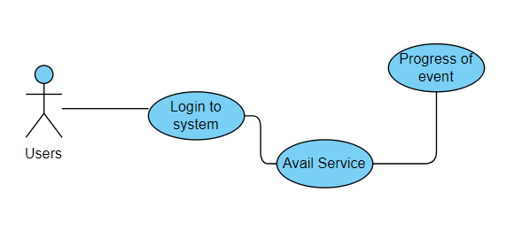

|  |  |  |  |  |
| --- | --- | --- | --- | --- |
| ***UC6: Event Progress*** | | | | |
| ***Use case Id:*** | | *Uc6* | | |
| ***Actors:***  *users* | | | | |
| ***Feature:*** *Event Progress* | | | | |
| ***Pre-condition:*** | | *Service Active by user* | | |
| ***Scenarios:*** *Services provider want to add new services.* | | | | |
| ***Step#*** | ***Action*** | | | ***Software Reaction*** |
| ***1.*** | *Enter email password* | | | *Login to the system* |
| ***2.*** | *Click on Add service button* | | | *Add new Services* |
| ***3*** | *Open dashboard* | | | *See Progress* |
|  |  | | |  |
| ***Alternate Scenarios:*** | | | | |
| ***1 :*** *. If the service provider tries to add a service with incomplete or invalid information, the system displays error messages prompting the provider to correct the entries.*   1. *Service is not started properly.* | | | | |
| ***Post Conditions:*** *View Services service providers.* | | | | |
| ***Step#*** | ***Description*** | | | |
| ***1*** | *Progress will be seen by users and service provider.* | | | |
| ***2*** |  | | | |
|  |  | | | |
| ***Use Case Cross referenced*** | | | *Uc3,UC4 or UC5* | |

### 4.2.7. E-Card Generation

|  |  |  |  |  |
| --- | --- | --- | --- | --- |
| ***UC7: Generate E-cards*** | | | | |
| ***Use case Id:*** | | *UC7* | | |
| ***Actors:***  *users* | | | | |
| ***Feature:*** *E-cards* | | | | |
| ***Pre-condition:*** | | *Users should be login to the system.* | | |
| ***Scenarios:*** *user want to create e-cards and sent it to their guest.* | | | | |
| ***Step#*** | ***Action*** | | | ***Software Reaction*** |
| ***1.*** | *Enter email password* | | | *Login to the system* |
| ***2.*** | *Click on generate cards* | | | *Cards generated with multiples templates* |
| ***3*** | *Sent to guest* | | | *Send to guest* |
|  |  | | |  |
| ***Alternate Scenarios:*** | | | | |
| ***1 :*** *.* | | | | |
| ***Post Conditions:*** *E card generated and sended to the guests.* | | | | |
| ***Step#*** | ***Description*** | | | |
| ***1*** | *Generate the card* | | | |
| ***2*** | *Select specific card* | | | |
|  |  | | | |
| ***Use Case Cross referenced*** | | | *UC2* | |

### 4.2.8. Guest invitation

|  |  |  |  |  |
| --- | --- | --- | --- | --- |
| ***UC8: Guest Invitation*** | | | | |
| ***Use case Id:*** | | *Uc8* | | |
| ***Actors:***  *users* | | | | |
| ***Feature:*** *Invite Guests* | | | | |
| ***Pre-condition:*** | | *Contact number should be added.* | | |
| ***Scenarios:*** *User want to add new guests.* | | | | |
| ***Step#*** | ***Action*** | | | ***Software Reaction*** |
| ***1.*** | *Select the contacts number* | | | *Select Guests* |
| ***2.*** | *Confirm the users* | | | *Check the list* |
| ***3*** | *Invitation sended* | | | *Sent invitation* |
|  |  | | |  |
| ***Alternate Scenarios:*** | | | | |
| ***1 :*** *. If the service provider tries to add a service with incomplete or invalid information, the system displays error messages prompting the provider to correct the entries.*   1. *Service is not started properly.* | | | | |
| ***Post Conditions:*** *View Services service providers.* | | | | |
| ***Step#*** | ***Description*** | | | |
| ***1*** | *Progress will be seen by users and service provider.* | | | |
| ***2*** |  | | | |
|  |  | | | |
| ***Use Case Cross referenced*** | | | *Uc3,UC4 or UC5* | |

### 4.2.9. Communicate and View messages.

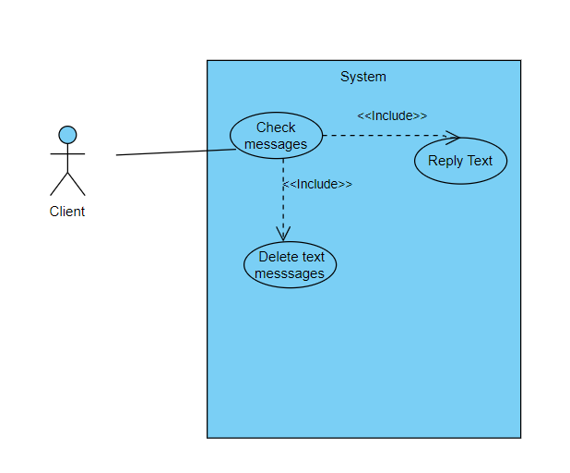

|  |  |  |  |  |
| --- | --- | --- | --- | --- |
| ***UC9: Communicate and View messages*** | | | | |
| ***Use case Id:*** | | *UC9* | | |
| ***Actors:***  *Users and Service provider* | | | | |
| ***Feature:*** *Check Messages* | | | | |
| ***Pre-condition:*** | | *The user type needs to be a client and they need to be logged in.* | | |
| ***Scenarios:*** *Users and Service provider wants to view the messages.* | | | | |
| ***Step#*** | ***Action*** | | | ***Software Reaction*** |
| ***1.*** | *User clicks on the text messages button.* | | | *Redirects the user to the inbox of the text messages.* |
| ***2.*** | *Clicks on reply section* | | | *Opens the text box for typing message.* |
| ***3.*** | *User clicks on delete button.* | | | *The Text disappears as it is deleted.* |
| ***Alternate Scenarios:*** | | | | |
| ***1a:*** *The user does not use the service.* | | | | |
| ***Post Conditions:*** *After successful completion the user can choose what to do with the messages.* | | | | |
| ***Step#*** | ***Description*** | | | |
|  |  | | | |
|  |  | | | |
|  |  | | | |
| ***Use Case Cross referenced*** | | | *uc2* | |

### 4.2.10 Avail Service

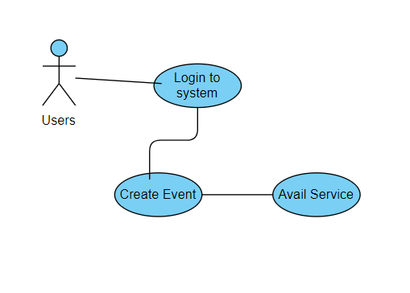

|  |  |  |  |  |
| --- | --- | --- | --- | --- |
| ***UC10: Avail service*** | | | | |
| ***Use case Id:*** | | *Uc10* | | |
| ***Actors:***  *users* | | | | |
| ***Feature:*** *Avail Service* | | | | |
| ***Pre-condition:*** | | *The user must be logged in to the system.*  *The user must have created an event.*  *Service providers must have listed their services in the system..* | | |
| ***Scenarios:*** *Users have to organize new events.* | | | | |
| ***Step#*** | ***Action*** | | | ***Software Reaction*** |
| ***1.*** | *User navigates to the service availment section of the system* | | | *The system displays a list of available services categorized by type.* |
| ***2.*** | *User selects the type of service they require for their event (e.g., venue, catering, decorations)* | | | *the system presents a list of service providers offering the selected type of service, along with details such as service description, pricing, and reviews* |
| ***3*** |  | | |  |
|  |  | | |  |
| ***Alternate Scenarios:*** | | | | |
| ***1 :*** *.*  *If the user's preferred service provider is not available for the specified date and time, the system prompts the user to choose an alternative provider or adjust the event detail* | | | | |
| ***Post Conditions:*** *The user successfully avails the desired service for their event.* | | | | |
| ***Step#*** | ***Description*** | | | |
| ***1*** | *Search for service* | | | |
| ***2*** | *Avail that service* | | | |
| ***3*** | *Communicate the Service provider* | | | |
| ***Use Case Cross referenced*** | | | *UC2* | |

### 4.2.11 Invite Member

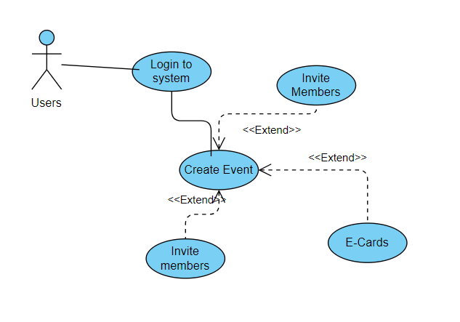

|  |  |  |  |  |
| --- | --- | --- | --- | --- |
| ***UC11: Invite Member*** | | | | |
| ***Use case Id:*** | | *Uc11* | | |
| ***Actors:***  *user and Guests* | | | | |
| ***Feature:*** *Invite Member* | | | | |
| ***Pre-condition:*** | | *Contact number should be added. The event organizer must be logged in to the system and the event must be created and in the planning stage.* | | |
| ***Scenarios:*** *User want to help to create event or share their tasks* | | | | |
| ***Step#*** | ***Action*** | | | ***Software Reaction*** |
| ***1.*** | *Event organizer navigates to the event management section of the system* | | | *The system presents options for managing the selected event* |
| ***2.*** |  | | |  |
| ***3*** |  | | |  |
|  |  | | |  |
| ***Alternate Scenarios:*** | | | | |
| ***1 :*** *.*  *If the event organizer enters an invalid email address or phone number, the system displays an error message prompting the organizer to correct the entry* | | | | |
| ***Post Conditions:*** *Now member will help to create event.* | | | | |
| ***Step#*** | ***Description*** | | | |
| ***1*** | *Invitations are successfully sent to the specified guests.* | | | |
| ***2*** |  | | | |
|  |  | | | |
| ***Use Case Cross referenced*** | | | *UC2, UC10* | |

### 4.2.12 Initialization budget

|  |  |  |  |  |
| --- | --- | --- | --- | --- |
| ***UC12: Initialization budget*** | | | | |
| ***Use case Id:*** | | *Uc12* | | |
| ***Actors:***  *users* | | | | |
| ***Feature:*** *Make budget* | | | | |
| ***Pre-condition:*** | | *The user must be logged in to the system.*  *The user must have created an event* | | |
| ***Scenarios:*** *Users want to make not to excite budget.* | | | | |
| ***Step#*** | ***Action*** | | | ***Software Reaction*** |
| ***1.*** | *User selects the event for which are under budget* | | | *The system presents progress bar which show budget and if excite it will become red* |
| ***2.*** |  | | |  |
| ***3*** |  | | |  |
|  |  | | |  |
| ***Alternate Scenarios: UC2, UC10*** | | | | |
| ***1 :*** *.*  *If the user tries to initialize the budget with an invalid amount (e.g., negative value or non-numeric input), the system displays an error message prompting the user to correct the entry.* | | | | |
| ***Post Conditions:*** *Maintain the event within budget* | | | | |
| ***Step#*** | ***Description*** | | | |
| ***1*** | *The budget for the event is successfully initialized with the specified amount.* | | | |
| ***2*** | *The user can start managing the budget by adding income and expenses.* | | | |
|  |  | | | |
| ***Use Case Cross referenced*** | | | *UC2, UC10* | |

### 4.2.13 Review and Rating to Service provide

|  |  |  |  |  |
| --- | --- | --- | --- | --- |
| ***UC13: Rate the Service Provider*** | | | | |
| ***Use case Id:*** | | *Uc13* | | |
| ***Actors:***  *users and members* | | | | |
| ***Feature:*** *Rate and feedback* | | | | |
| ***Pre-condition:*** | | *The user must be logged in to the system.*  *The user must have availed a service from a service provider.* | | |
| ***Scenarios:*** *for users authentication users will provide the feedback and reviews* | | | | |
| ***Step#*** | ***Action*** | | | ***Software Reaction*** |
| ***1.*** | *User navigates to the feedback section of the system.* | | | *The system displays a list of recent services availed by the user and options for providing feedback and ratings* |
| ***2.*** | *User selects the service for which they want to provide feedback and rating.* | | | *The system presents details of the selected service, including the service provider's information and the service availed.* |
| ***3*** |  | | |  |
|  |  | | |  |
| ***Alternate Scenarios:*** | | | | |
| ***1 :*** *.*  *If the user chooses not to provide a rating or feedback, the system allows them to skip this step and return to the main feedback section.* | | | | |
| ***Post Conditions:*** *Good working Service Provider get more rating and satisfy the users* | | | | |
| ***Step#*** | ***Description*** | | | |
| ***1*** | *User successfully provides feedback and rating for the service provider.* | | | |
| ***2*** |  | | | |
|  |  | | | |
| ***Use Case Cross referenced*** | | | *UC2, UC10* | |

### 

### 4.2.14 Event Progress

|  |  |  |  |  |
| --- | --- | --- | --- | --- |
| ***UC14: Event Progress*** | | | | |
| ***Use case Id:*** | | *Uc14* | | |
| ***Actors:***  *Service providers and users* | | | | |
| ***Feature:*** *Event Progress* | | | | |
| ***Pre-condition:*** | | *Service Active by user* | | |
| ***Scenarios:*** *Services provider want to add new services.* | | | | |
| ***Step#*** | ***Action*** | | | ***Software Reaction*** |
| ***1.*** | *Enter email password* | | | *Login to the system* |
| ***2.*** | *Click on Add service button* | | | *Add new Services* |
| ***3*** | *Open dashboard* | | | *See Progress* |
|  |  | | |  |
| ***Alternate Scenarios:*** | | | | |
| ***1 :*** *. If the service provider tries to add a service with incomplete or invalid information, the system displays error messages prompting the provider to correct the entries.*   1. *Service is not started properly.* | | | | |
| ***Post Conditions:*** *View Services service providers.* | | | | |
| ***Step#*** | ***Description*** | | | |
| ***1*** | *Progress will be seen by users and service provider.* | | | |
| ***2*** |  | | | |
|  |  | | | |
| ***Use Case Cross referenced*** | | | *Uc3,UC4 or UC5* | |

# 5. Non-functional Requirements

### 

### 5.1. Performance Requirements

* The system must provide fast loading times and responsive user interface.
* System downtime should be minimal, with 24/7 availability.
* The system should operate reliably under not only normal but also peak load conditions.
* This system will support multiple users concurrently without degradation in performance.
* This system will accurately handle and process user inputs, calculations, and data manipulations.

### 5.2. Safety Requirements

The system must incorporate features and safeguards to protect users from harm or injury while interacting with the platform. This includes providing clear instructions, warnings, and guidelines for safe usage, especially for features involving physical activities or events.

### 5.3. Security Requirements

This system must implement secure user authentication mechanisms to verify the identity of users accessing the platform. This includes features such as password-based authentication. On the other hand , system will filter service providers on the basis of their rating.

### 5.4. User Documentation

We will be using software wizard to demonstrate the project.

# 6. References

Not applicable

# 7. Appendices

Not applicable